Introduction
The DTUSat2 is a student project at DTU spanning multiple engineering disciplines. The goal of the project is to send a satellite into space and use it to collect bird migration data.
The satellite has a built-in failsafe mode that will get executed if the norminal mode for some reason fails. The DTUSat2 staff needs a simple and flexible way of controlling the failsafe mode. The goal of this project is to analyse the needs of the staff, design and investigate different solutions and finally produce a piece of software based upon the agreed design.

Specification
The following specifications have been extracted from the first couple of meetings with Hans Henrik Løvengreen.
The DTUsat2 staff must be able to do the following using the software of this project:
- Interact with the satellites failsafe mode from a desktop computer
- Upload new software, run tests and perform diagnosticts via scripts
- Read logs of user-sessions and scripts

Analysis & Design
Replace linux with any *nix environment of choice in the following:
The failsafe control software is distributed over several layers to provide flexibility and ease of use. The main component of the system is the Failsafe Daemon that has the following specification:
- Runs as a daemon in a linux environment.
- Has a RS-232 connection directly to the satellite or indirectly through the Ground Station.
- Listens for incomming Failsafe Commands on a linux port.
- Validates incomming Failsafe Commands.
- Logs requests and responses to a logfile.
The Failsafe Console Client is a linux command line tool that takes a Failsafe Command and its parameters as arguments and forwards the request to the Failsafe Daemon over TCP. The response from the Failsafe Daemon is printet to standard out. In effect this turns the satellite into a unix file that adheres to the key design principle of unix: “Everything is a file”. This plugs the software right into the applications and tools already running on linux and ensures compatibility for future applications that follows this simple guideline.

From a staff members point of view the interaction with the satellites takes place in a browser or in a terminal depending on the task at hand.

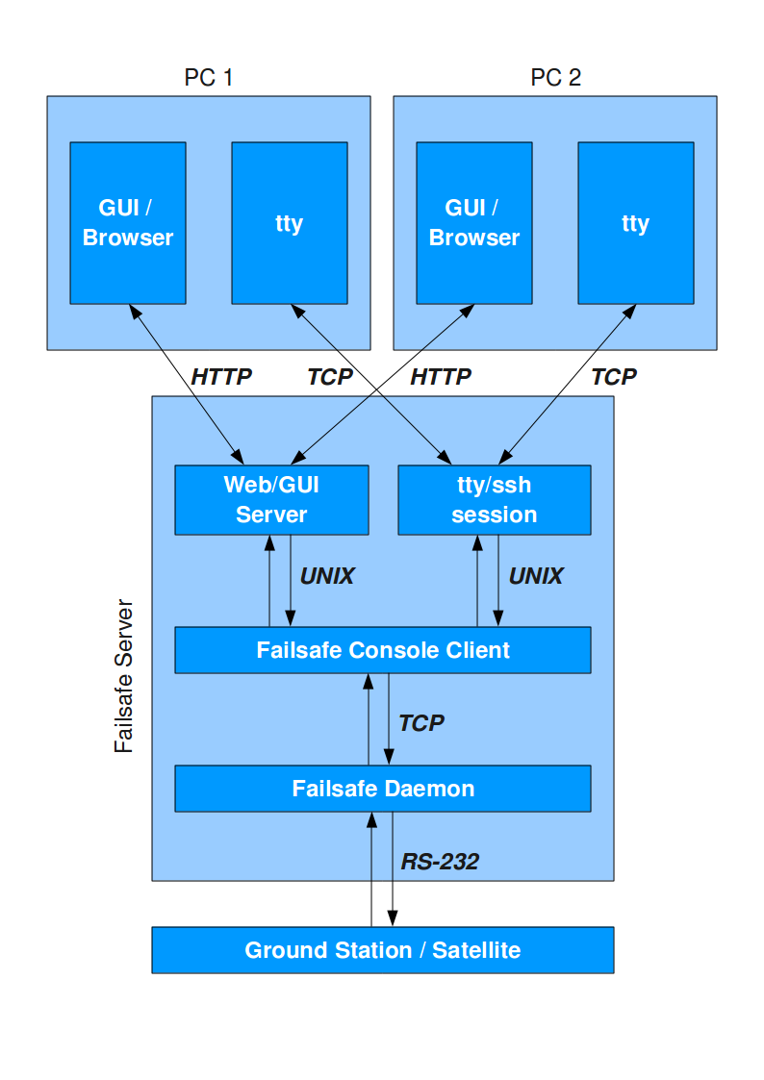
Transactions
There has to be a mechanism that prevents users from executing scripts simultaneously. Here are some possible solutions.

The failsafe daemon only accepts one tcp connection at a time
The problem here is that this only works for

The failsafe daemon provides lock/release session mechanism

Monitoring

